Setup & Firmware Uploading Guide
Smart Speaker

Assembly Guide

- Connect the Speaker connecting cable to the speaker
carefully solder the Black wire to the Speaker terminals marked (-Ve) and Red wire to speaker terminal marked (+Ve). As shown in figure: 3
After soldering the wires connect the speaker connector as shown in figure 2 to the Speaker connector J9 as shown in Figure 1

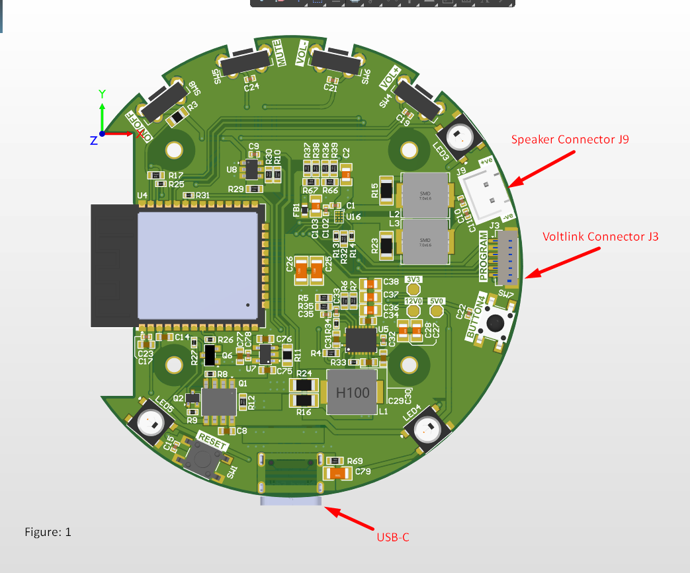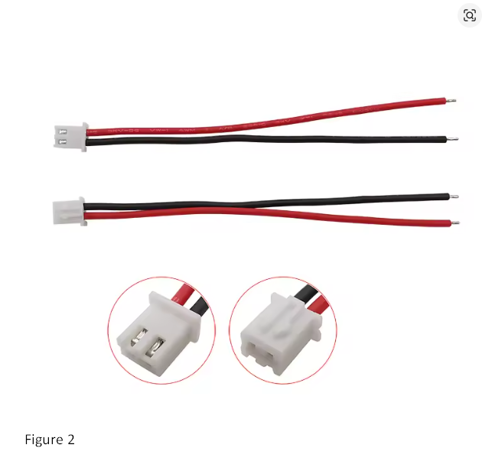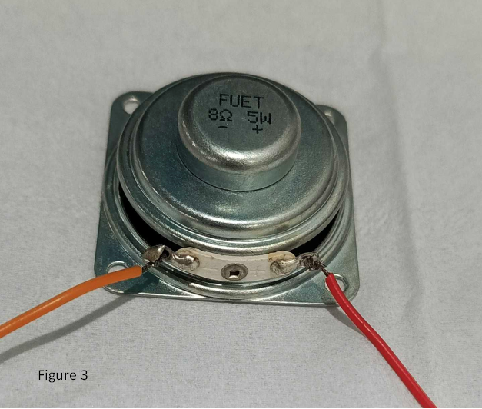

- Prepare the Board for programming by connecting it to Voltlink programmer as shown in Figure 4
Use the connection cable provided with the Voltlink adapter to connect with the Voltlink connector marked J3 in the Board
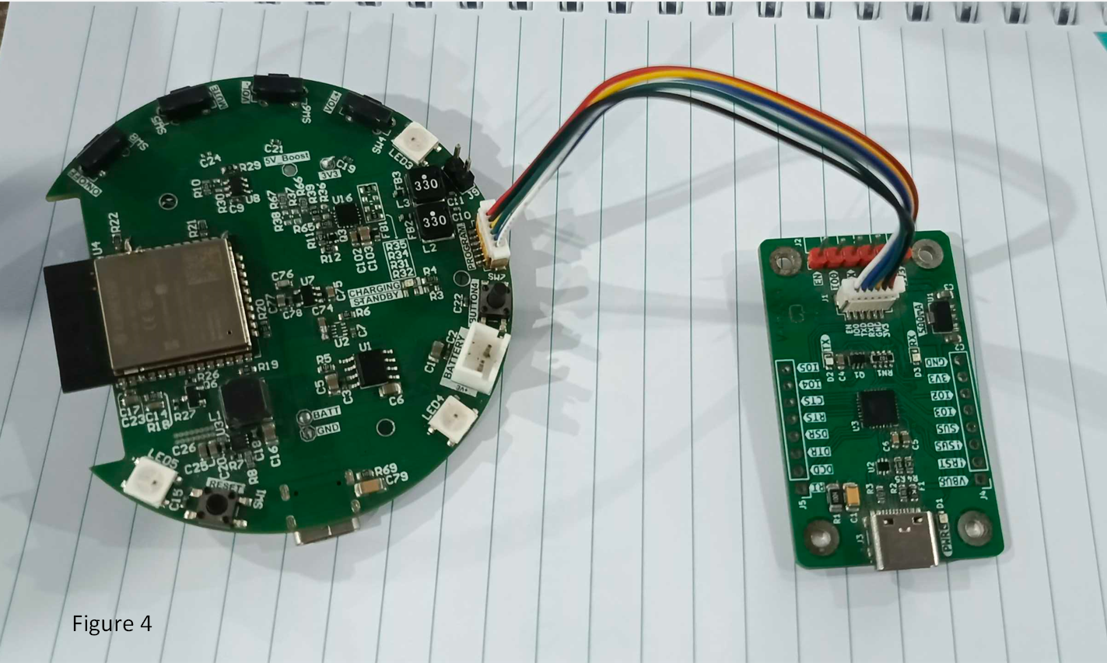

Set up the firmware upload and development environment:

Step 1. Set up Arduino IDE
Arduino IDE can be downloaded from the Arduino website: https://www.arduino.cc/en/Main/Software
When the installation is finished, open Arduino IDE. Go to “File” -> “Preferences”.
And paste the following URL into the “Additional Boards Manager URLs” field:
https://raw.githubusercontent.com/espressif/arduino-esp32/gh-pages/package_esp32_index.json
Step 2. Set up Arduino IDE for ESP32
Next, go to “Tools” -> “Board” -> “Boards Manager”: and search for ESP32 install the one by “Espressif systems” as shown in image below
The “Boards Manager” requires several seconds to refresh all hardware files
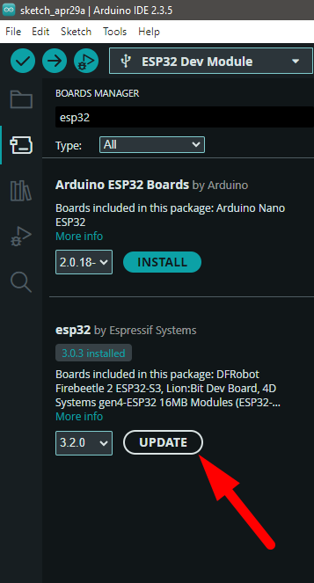

Now, go to “Tools” -> “Board” -> “esp32” ->Select ESP 32 Dev Module
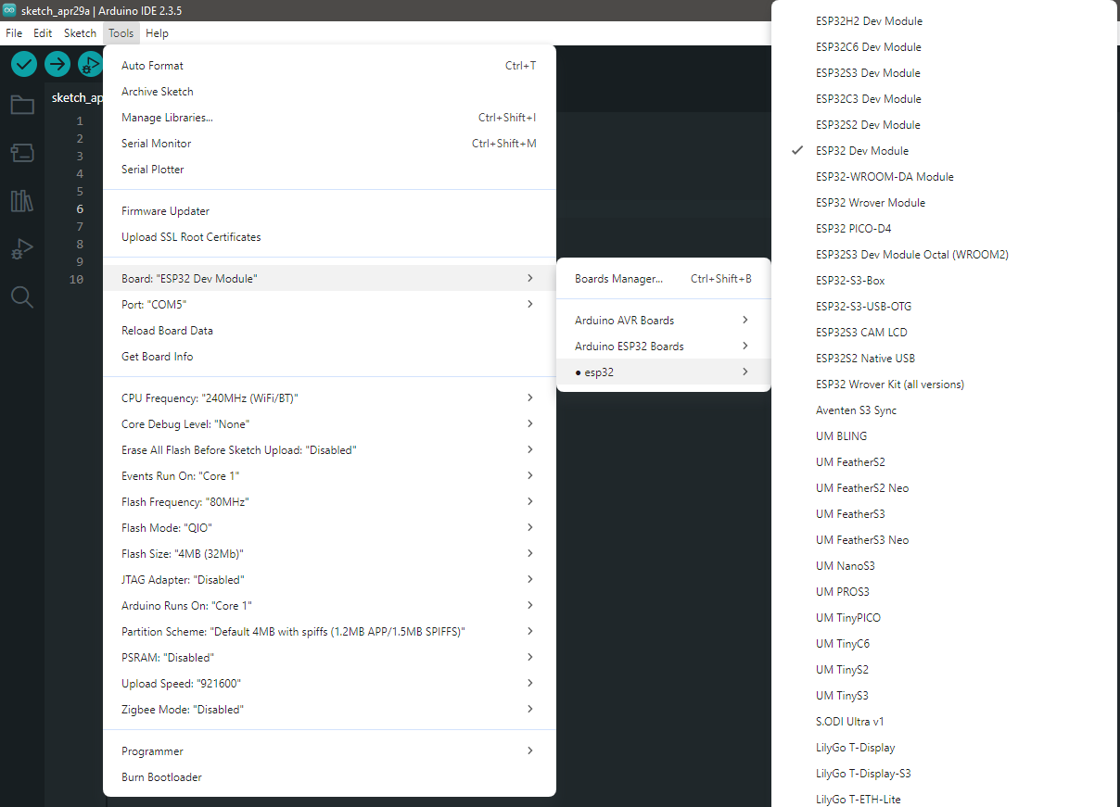

Step 3. Install the Serial port:
Make sure the Voltlink-board is connected to computer via Type-C USB.
After connected, the USB driver will be automatically installed. If there is any driver issue of connecting board, please go to CP210x USB to UART Bridge VCP Drivers - Silicon Labs for USB driver. Check the COM Port number in Device Manager for Windows OS user:
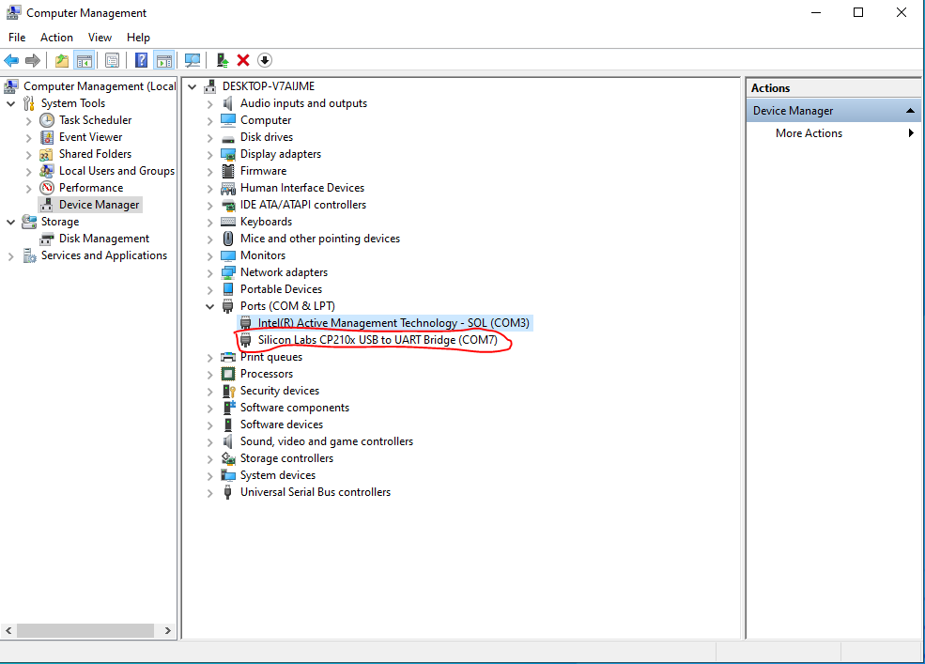
Now open the latest provided firmware
Next go to “Tools” -> “Port” and select the correct COM port.
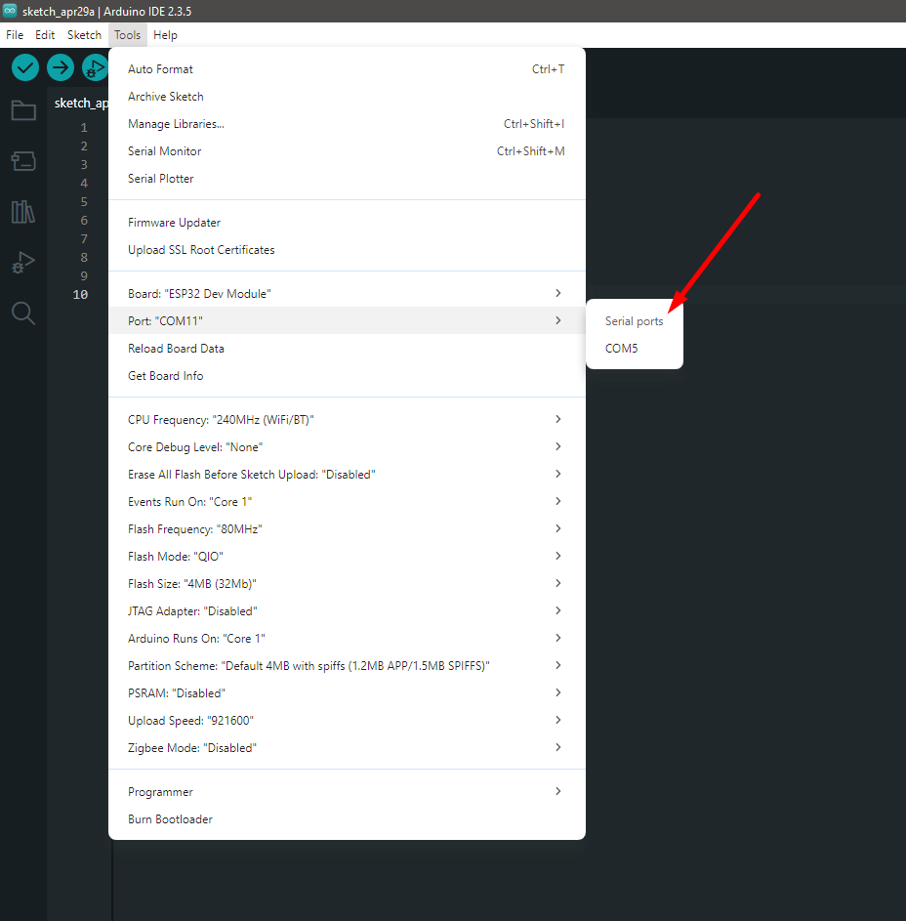
After selecting the correct COM port upload the code by pressing the upload button as mentioned below
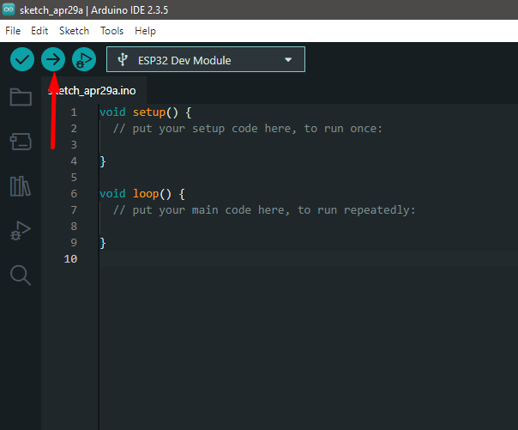

Hardware Testing Guide:

